**MODULE 2: WINDOWS PRACTICAL ASSIGNMENT**

**PART 1**

1. **Hardening of my computer**

Windows hardening means reducing the weakness and vulnerabilities in a system so that threat actors won’t exploit them. The following are the windows hardening checklist that I used for my system

* Windows setting

I right clicked on the Local Drive

I clicked on properties.

Then I clicked on security tab to change or edit the permissions for each user or group(system).

After that I clicked OK.

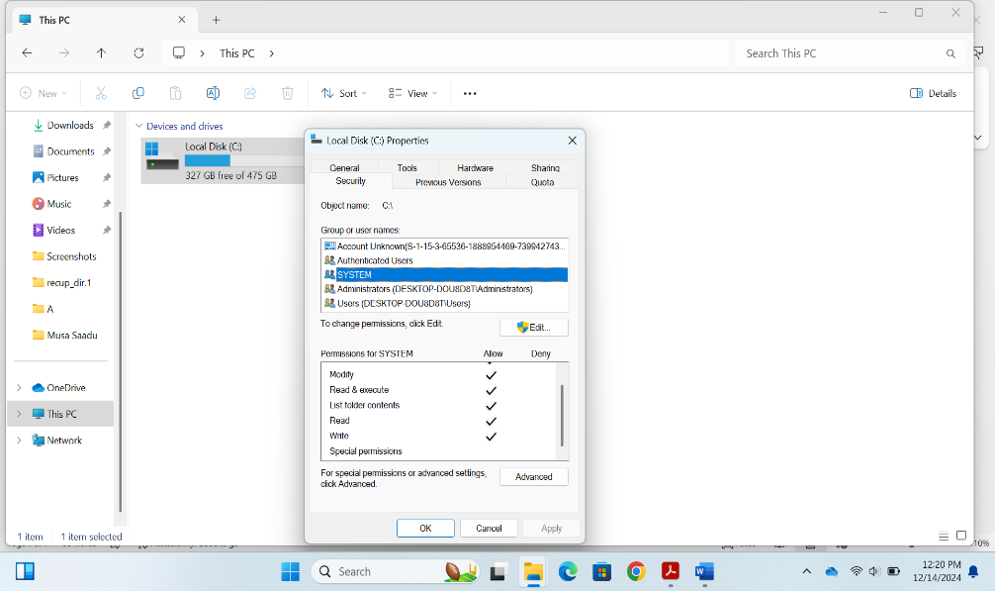

* Update: I did window update so as to keep my system secured.

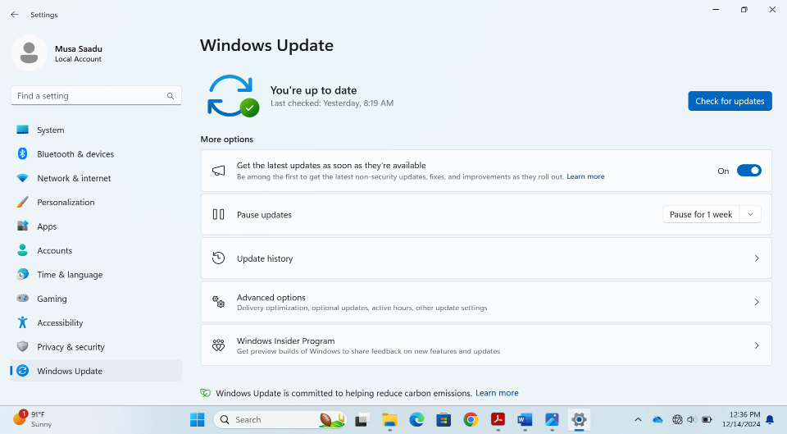

* Program and Features: I turned off windows features that are not useful to me.

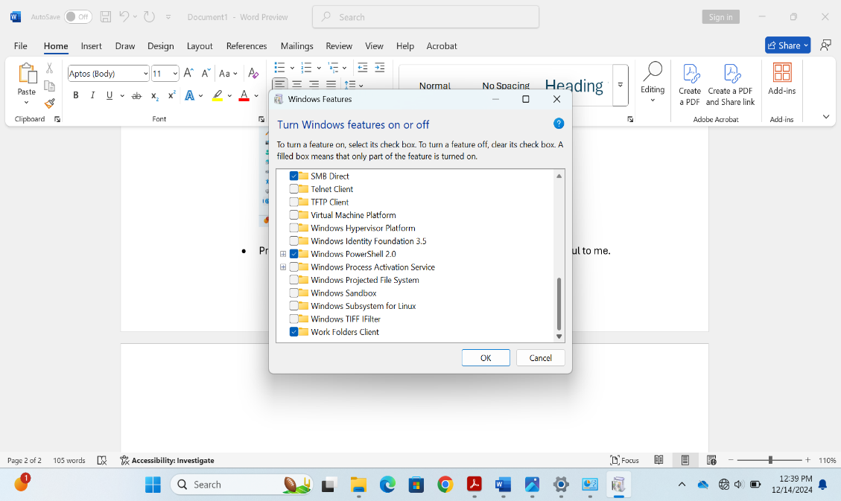

* Window Security: I clicked on App and browser Control then reputation based protection and enabled the features under it like phishing, potentially unwanted app blocking etc

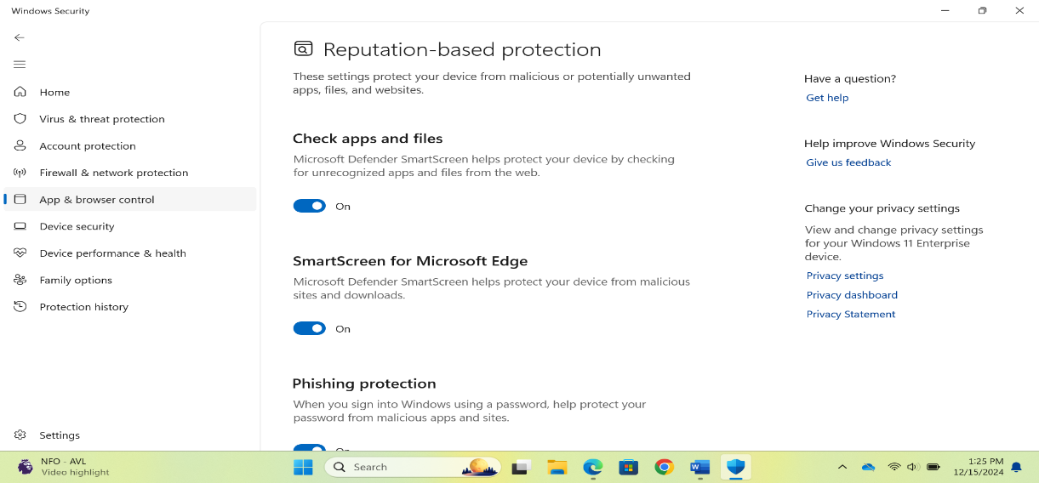

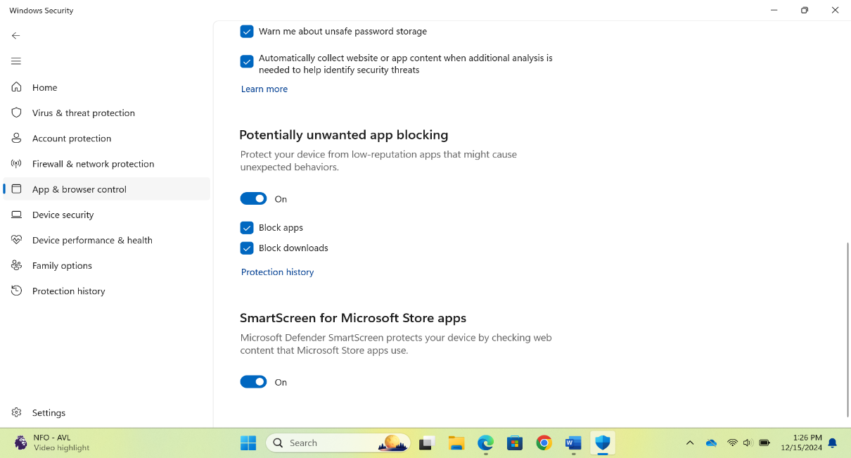

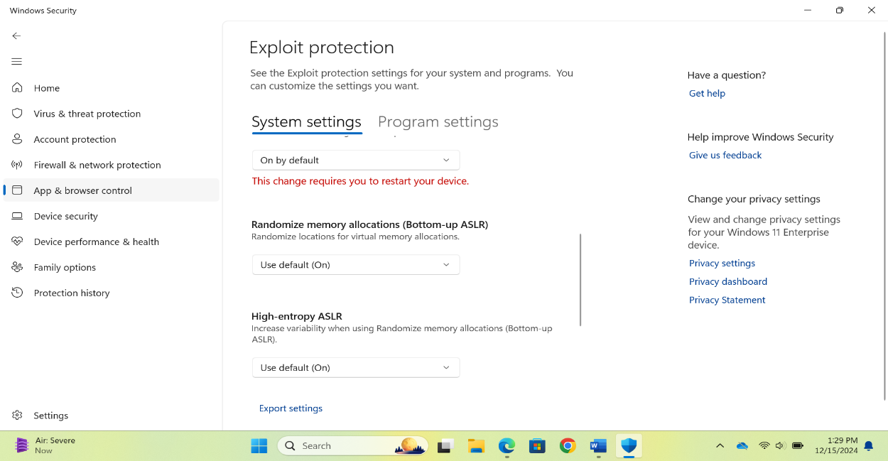

* Device Security:

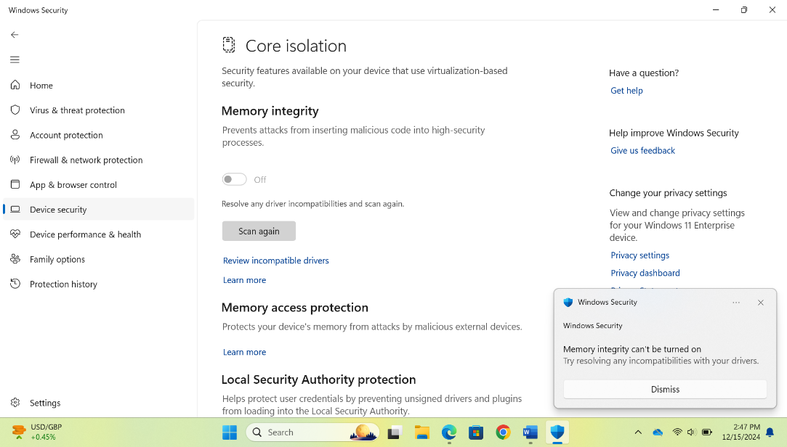

1. Configuration and Installation of Nessus on Windows Laptop

The following steps were taken in configuring and Installing Nessus scanner on my windows 11 laptop.

1. I googled for “download Nessus”

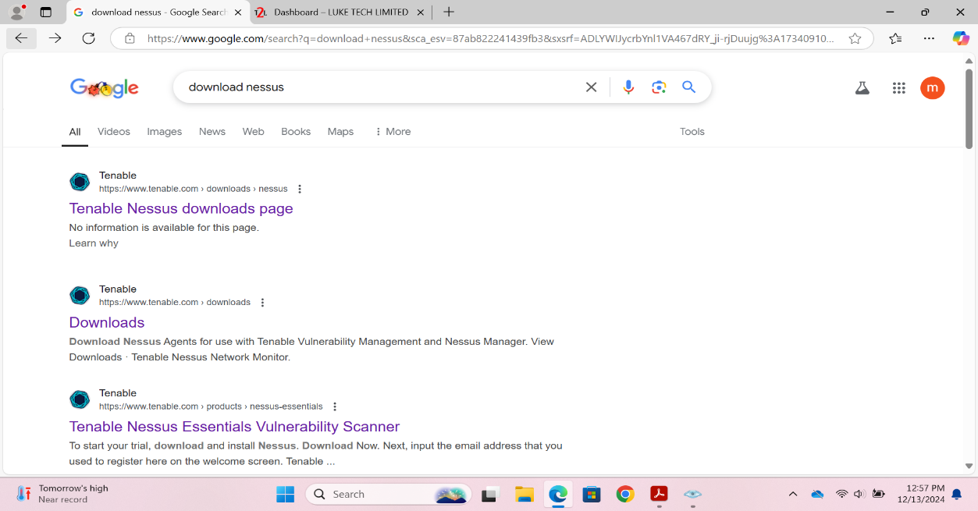

1. I clicked on Tenable Nessus downloads page

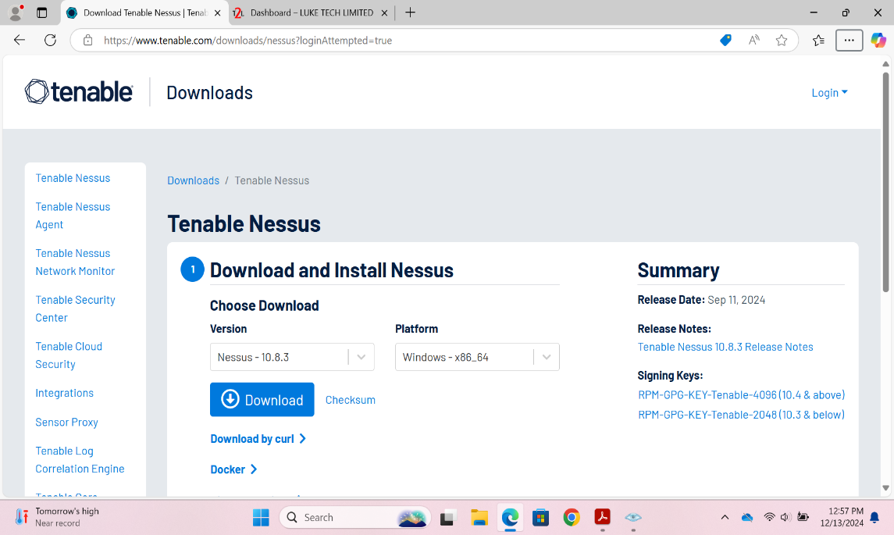

After selecting the platform, I clicked on Download button and downloaded the software.

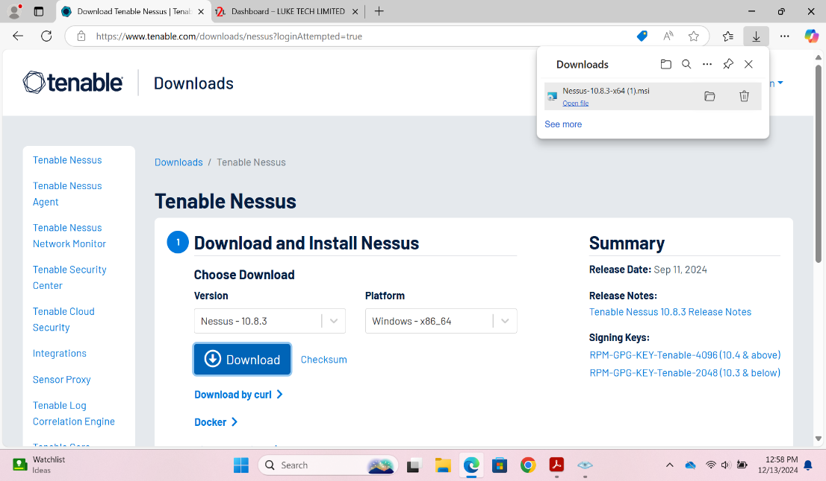

I installed the Nessus after accepting the license agreement

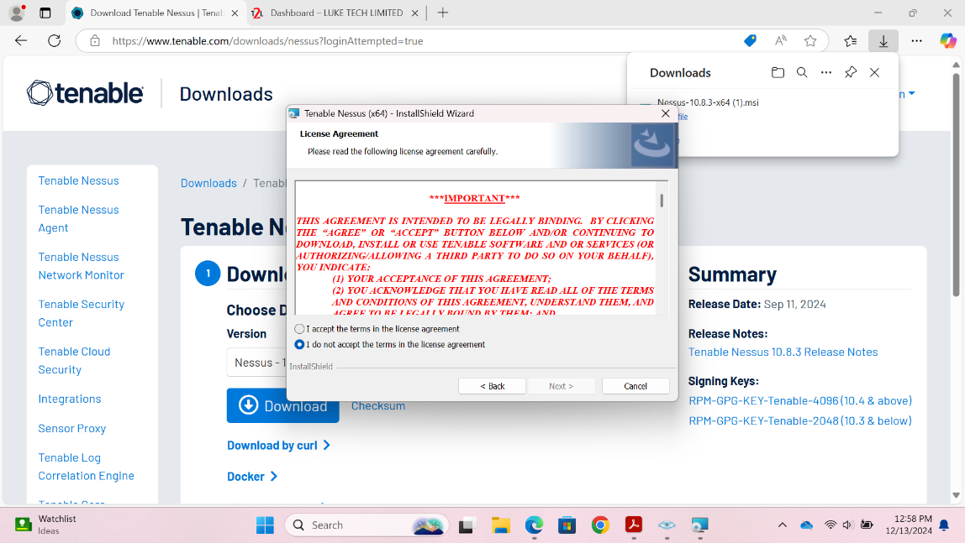

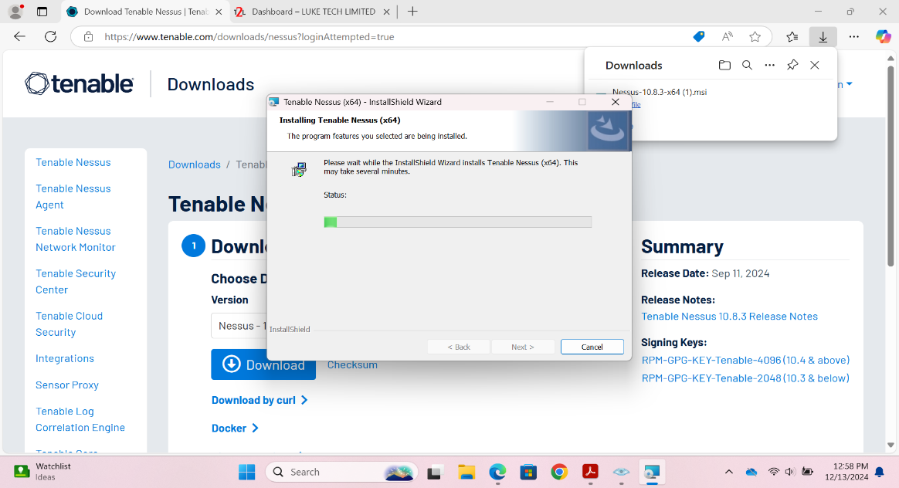

After that I clicked connect via SSL to initialize and get my activation code through a temporary email, temp email

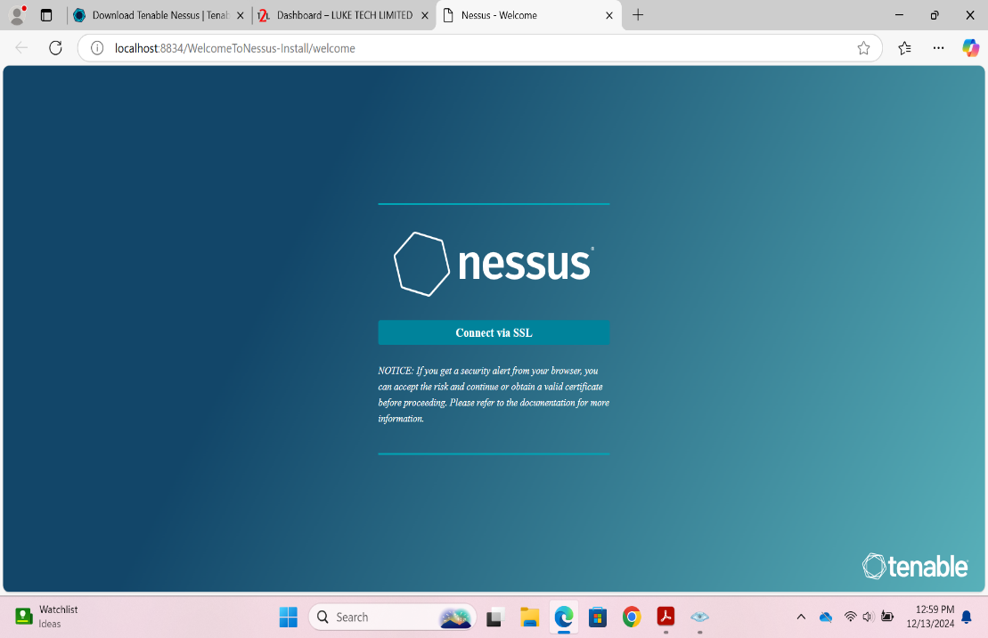

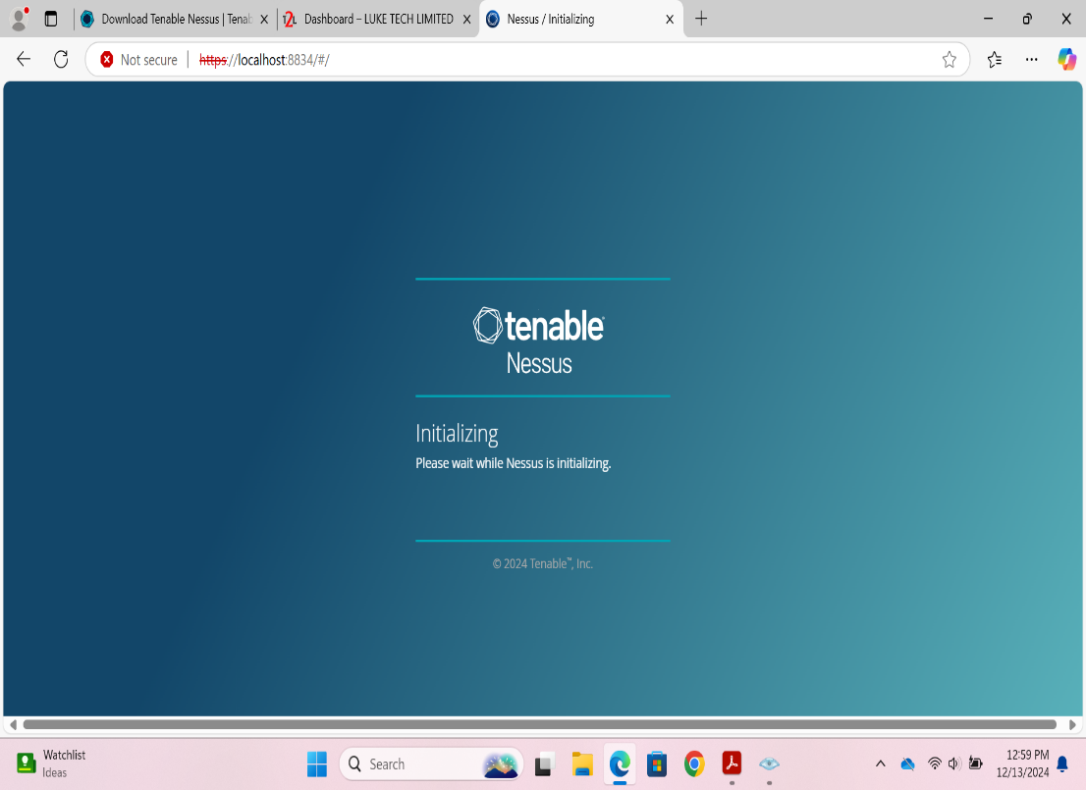

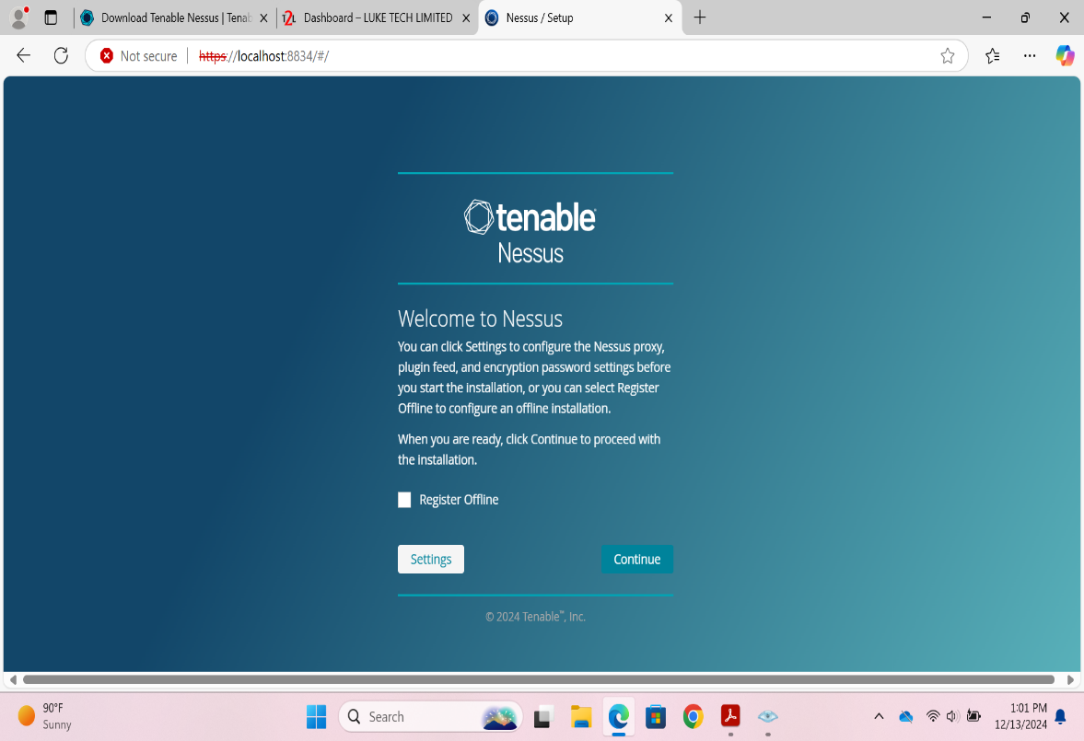

I clicked on continue to register for Nessus essentials, got my activation code, created an account and finally signed in to Nessus.

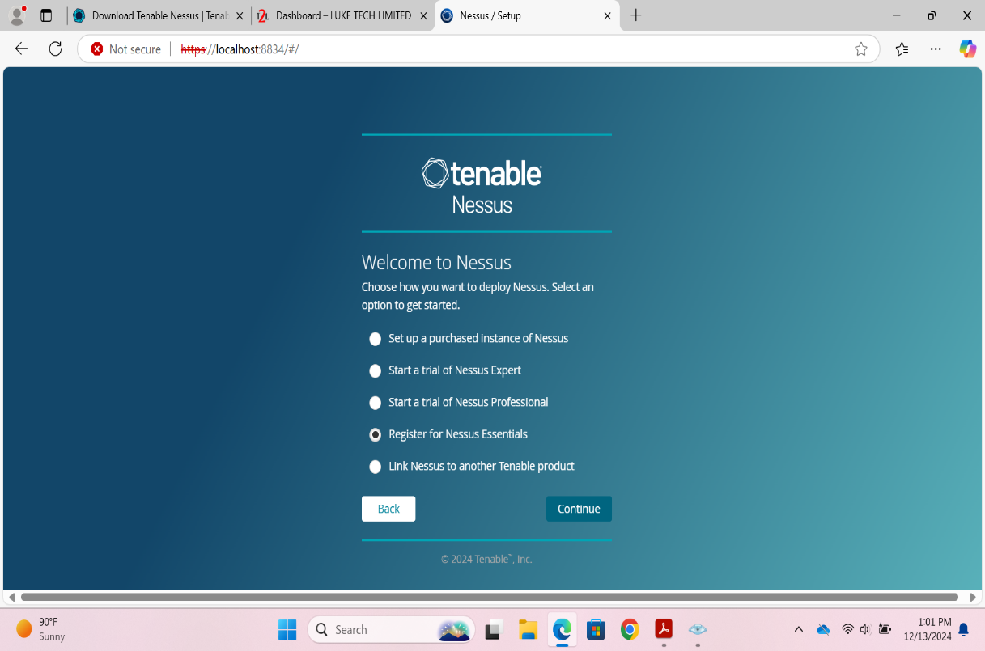

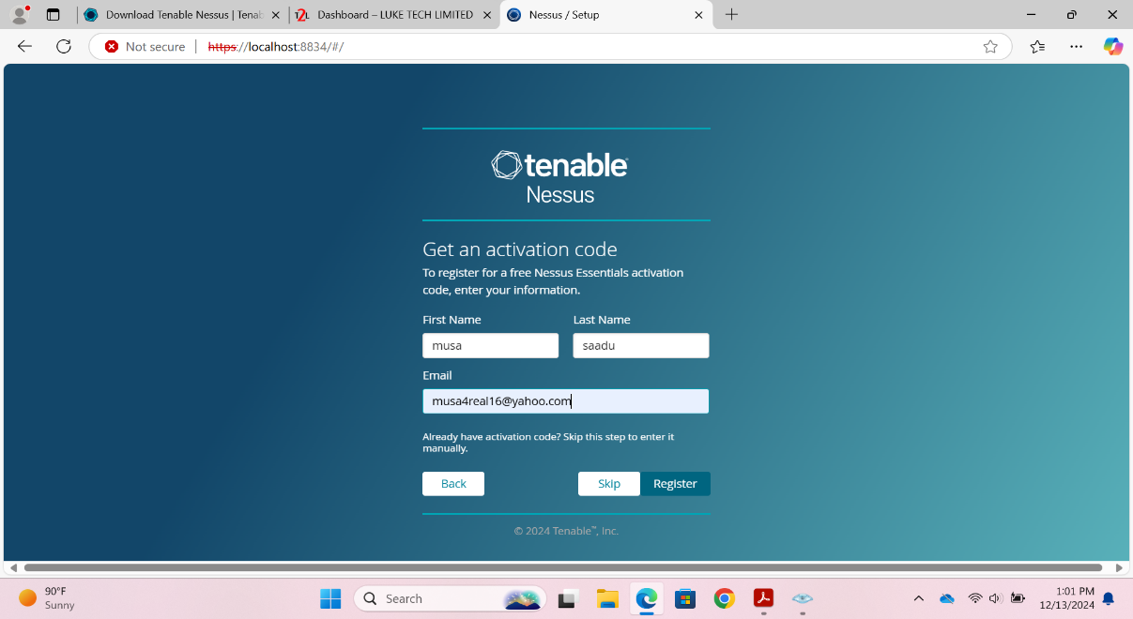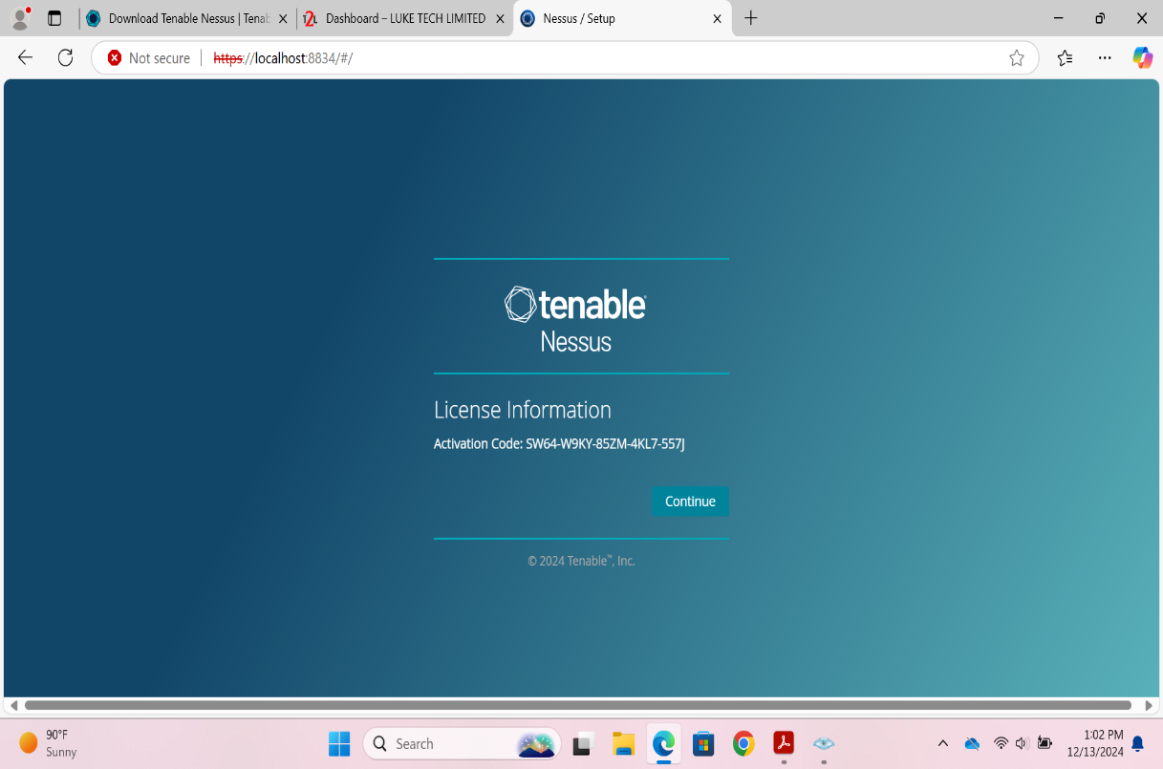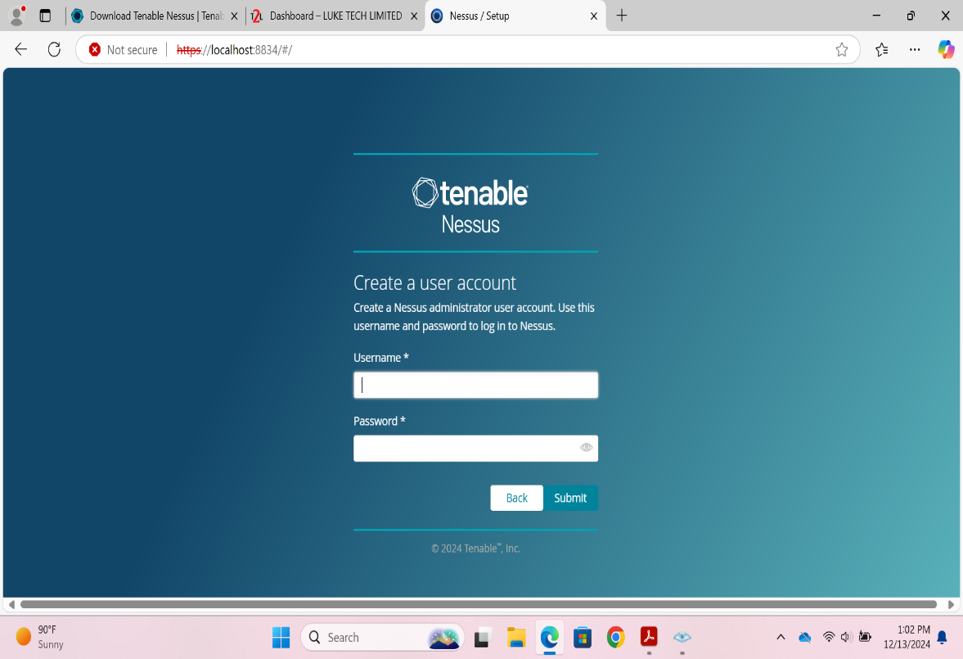

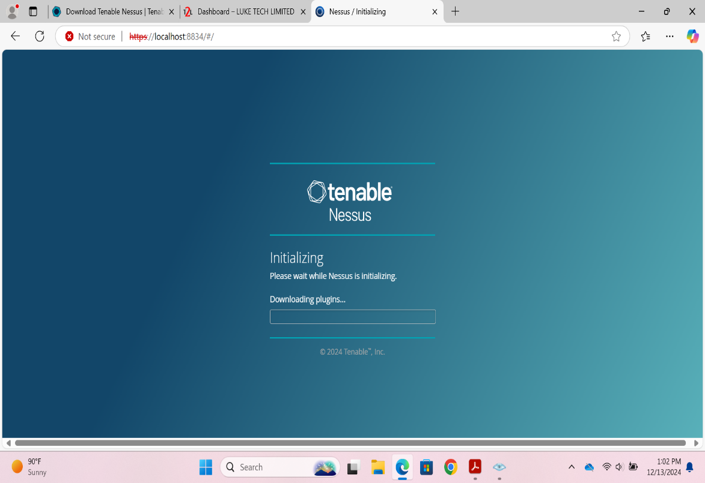

**Performing Vulnerability Scan using an IP Address of 127.0.0.1**

I logged into my Nessus account and I clicked on New Scan to pick the scan templates

Under the Vulnerabilities templates, I selected Basic Network Scan

I entered the filled the necessary details and entered the target IP: 127.0.0.1

After that I launch the scan for vulnerabilities and I got the scan result as follow:

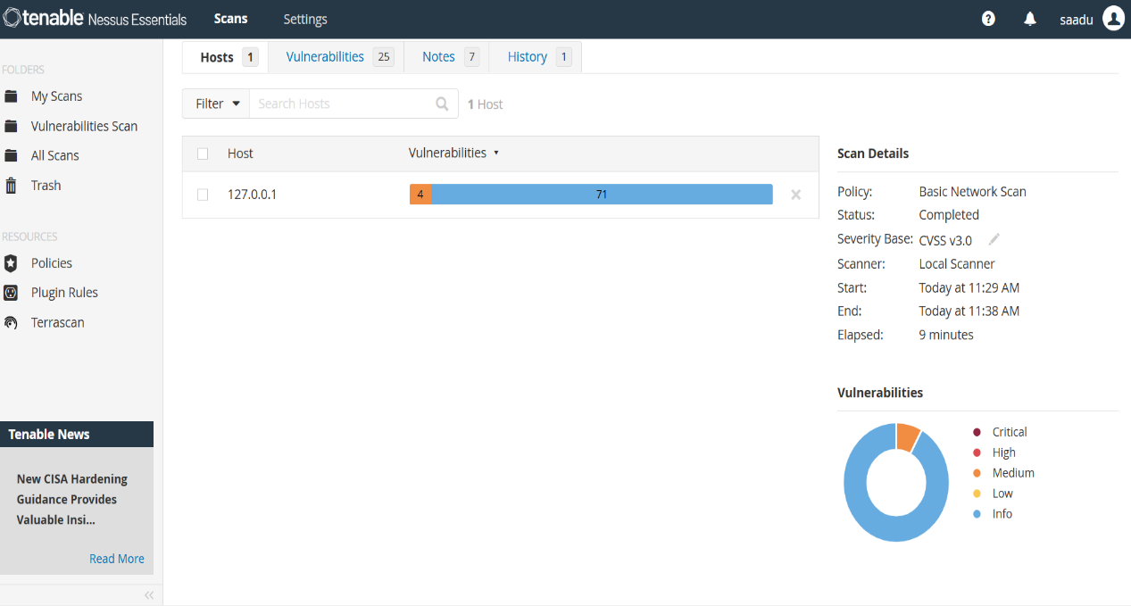

I cant generate the report in pdf and I reached out to one of the instructor on the telegram platform for solution. He connected via anydesk for solution but not resolved. The Nessus I am using is 10.8.3 which is different from the class video (the lecture was done 3 years ago). I opted for an excel format report.

**PART 2: LINKEDIN**

I have created a linked profile and followed Luke Tech Limited , update my educated to studying cybersecurity at Luke Tech Limited

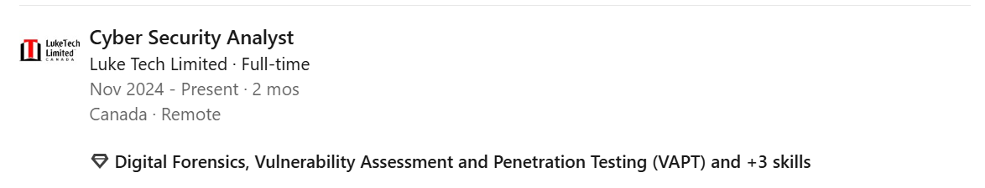

Have posted on LinkedIn and tagged Luke Tech Limited and Luke Iheme (also following the two accounts). Help me repost my posts to employers. Thanks.